Connect a bot to Cortana

* Open the bot on the [Bot Framework Portal](https://dev.botframework.com/), click the **Channels** tab, and then click **Cortana**.

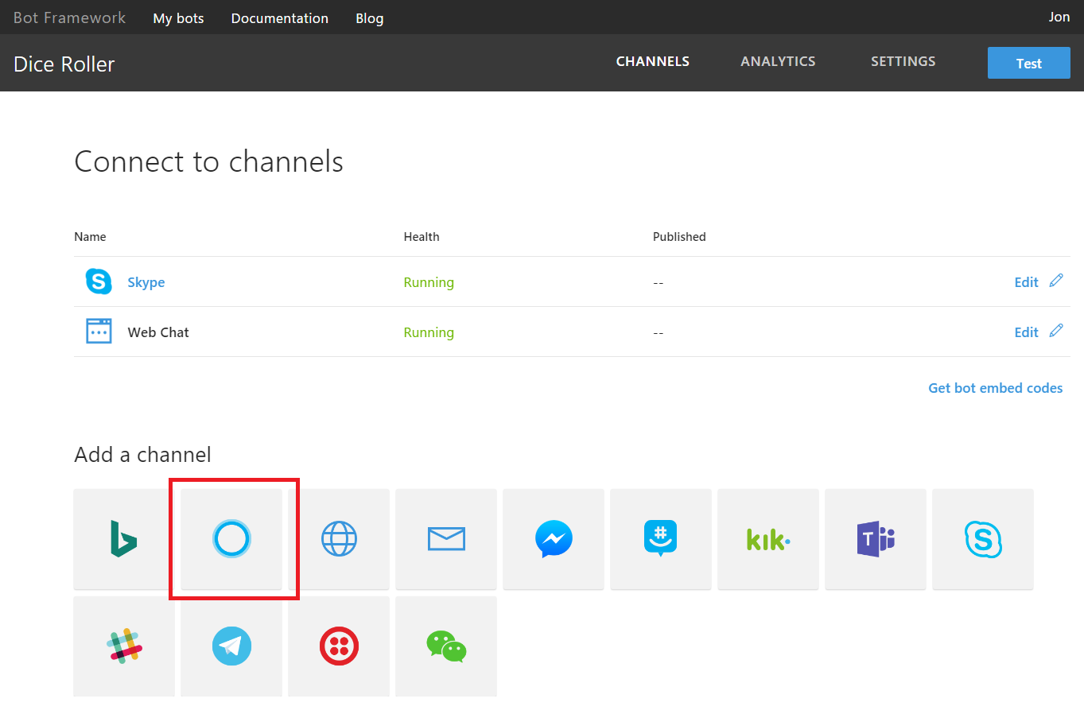

## **General bot information**

All fields marked with an asterisk (*) are required. Bots must be published on the Bot Framework before they can be connected to Cortana.

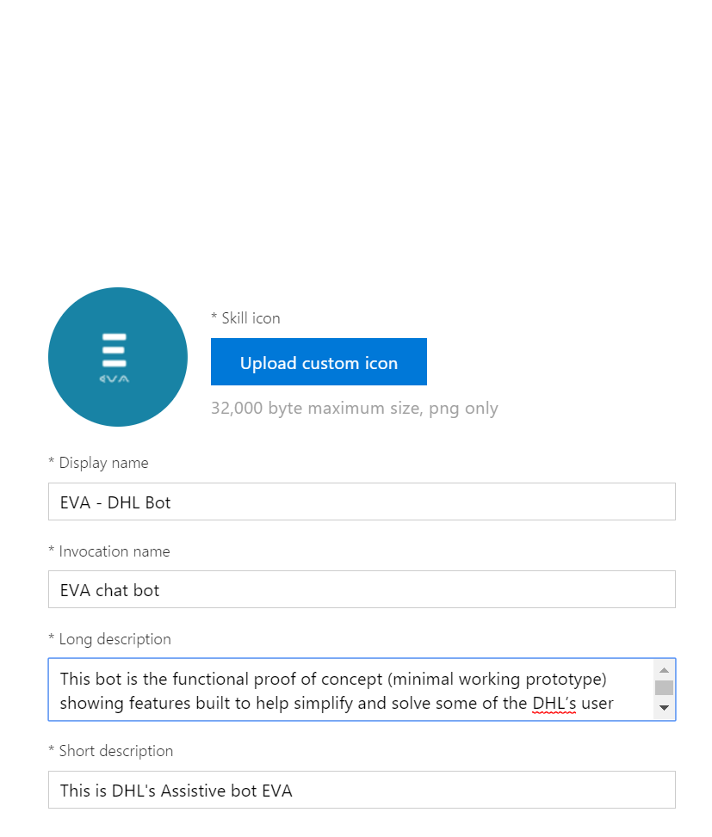

### **Skill Icon**

Select a custom icon to represent this bot. This icon is displayed in the Cortana canvas when this skill is invoked and anywhere skills are discoverable, such as the Microsoft store. The image must be a PNG, 60 x 60 pixels, and no larger than 30kb.

### **Display Name**

The name of this skill as displayed to the user at the top of Cortana's visual UI.

### **Invocation Name**

The name that Cortana will recognize and use to invoke this skill when spoken aloud by the user. See the [Invocation Name Guidelines](https://aka.ms/cortana-invocation-guidelines) for more information on how to choose this phrase.

### **Skill description**

Describe the skill. This is used where bots are discoverable, like the Microsoft store.

### **Short description**

This summary will be used to describe the skill in Cortana’s Notebook.

##### **Note**

For basic skills, this is all that is required. Click **Connect to Cortana** to complete the connection. For more advanced skills, add a connected account or configure access to user profile and contextual information.

Lastly save

Click on test at right corner to test the bot

